Larry Calkins -- Artist Statement

Time&place: my personal history goes back 5 generations in one place. My ancestors crossed the plains and homesteaded in the Harlan Valley, in Oregon, where I grew up. People in the valley depended on each other and formed a tight knit community. They raised cattle, sheep, farmed and logged trees for a living.

Many stories circulated as spoken history - some mysterious, some tragic, some encouraging, and many remain perplexing. These stories come alive in my art. For the observer they likely remain obscure, but my symbolism transcends and makes the the heart of the narrative emotionally accessible. Collectors from many walks of life respond to my work. There is an underlying meaning that triggers an emotional response.
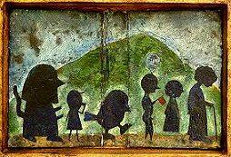
I developed my own symbols that mark my narratives: for example, the burning house represents change and disruption. Other houses stand for stability and connectedness, a place to be from or to belong. Small houses dot green mountains and each one holds a mystery unseen.
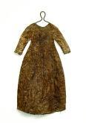
Rabbits and birds that populate my imagery are interchangeably good and evil, male and female, strong or weak. Appearances can be deceptive.

I am known for my dress sculptures. They appear plain in their countenance but are elegant in their simplicity. They embody the same symbolism but are abstract nature which allows the viewer to supply his/her own interpretation. I have been told of very strong emotional responses to my work.

Looking back to my childhood in the late fifties, life in the valley still seemed like that of pioneer times when a man could hack out a little clearing - as my father did - and with his own hands build a small shelter to raise a family. They survived with a few essentials. Houses were small and the work was honest. People didn’t plan to be rich, they just wanted to survive and be happy.

When you are closer to nature you are more content.
Birds replace radios. Evening sky replaces TV.
In winter the Big Elk River looks like coffee with cream.

Both parents never felt stifled by the isolation of a remote valley. My dad was very practical and my mother loved books and music. Their door was always open to young and old, to newcomers, and to the long-time residents of this ever changing community. We find that change IS inevitable when logging and farming provides a living.

My artwork is suffused with the world they opened up for me, condensed in a pictorial narrative, sometimes secretive, or humorous, or biting, sometimes dipping into the absurd and surreal undercurrent of a community steeped in personal tragedy - but also in the ever present hilarity of the unbroken human spirit.

It is dusk always in the hills of Harlan. Dusk is the color of waking dreams.

Everything happens at evening-tide. The flying rabbits come out. The bicycling crows appear. The houses catch fire and the moon glows a baleful yellow.
Dead salmon litter the banks of the Big Elk and all the neighbors lock their dogs away to save them.

Jet trails crisscross the sky. A little airplane flies over, pulling a banner that says “Remember the lake”.

Issaquah, WA, March 2014

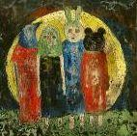

contact: calkinsart@comcast.com

Artist Info: http://calkinsart.net/html/artistinfo.html
About: (pictoral) http://calkinsart.com/about/
Reviews, show announcements, sold work http://calkinsart.com/sold/
Available artworks: http://calkinsart.net/thumbs/

Websites:
calkinsart.net, calkinsart.com and
noticewhatyounotice.com
Blogs:
calkinsART Newsletter

